Giinger

Revision: V0
Date: August 3, 2013
By: Guillaume, CTO
Country: Singapore

Objective of this document: This document aims to guide technical part for our proof of concept for safety equipment.

Concept: We want to allow a 2,4Ghz emitter to transmit some message to a mobile to verify the location of a person for a game.

Example :

Room 1

Smartphone reads
‘’00123’’

You are in Room 1 – you win

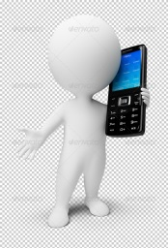

10 meters

Emitting @ 2,4 Ghz
An identifier (ID) ‘’00123’’

We think that we could be able to use a USB 2,4Ghzdongle to emit a unique ID as it is a cheap solution. The mobile phone then detects the ‘emitter signal, reads the unique ID (00123) and its signal strength.

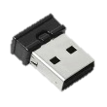
Exemple : nRF24LU1
http://www.semiconductorstore.com/cart/pc/viewPrd.asp?idproduct=13757
http://www.semiconductorstore.com/cart/pc/viewPrd.asp?idproduct=13759

Description:
- Emit a 2.4Ghz signal including a unique code/message .
- What we need: the software to program to program the USB dongle + a programmable USB emitter/receiver.
- The user should not need to turn on the WIFI or Bluetooth ! the app uses the antenna directly.
- We need to be able to read on the smartphone: Frequency , unique ID/message , signal strength.

Scenario - TEST : 1 laptop – 1 USB programmable Emitter/Receiver – 1 mobile

Validate that it works :
Step 1 : Program the USB hardware with a unique identifier (ID = 00123). The USB hardware emits a 2.4Ghz ‘’00123’’.
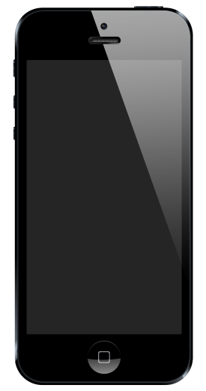
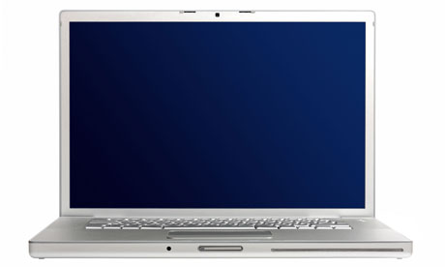
Software
Emit @ 2,4 Ghz
‘’00123’’
Software
Receive @ 2,4 Ghz
‘’00123’’
Strength :Xx dB

Step 2 : Once plug to any USB port the USB hardware still emit ‘’00123’’

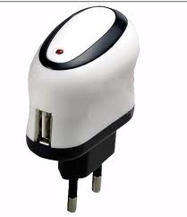
Emitting @ 2,4 Ghz
‘’00123’’
Iphone
reads
‘’00123’’
Strength :Xx dB

About 10meters

