Broad only Nrf52840 SOC
SDK: SDK17.1
IAR for arm V9.20

E73-2G4M08S1C nRF52840 SoC模块-物联网芯片,ZigBee无线模块协议,I/O接口,蓝牙4.2,SOC模块,片上系统模块 (ebyte.com)
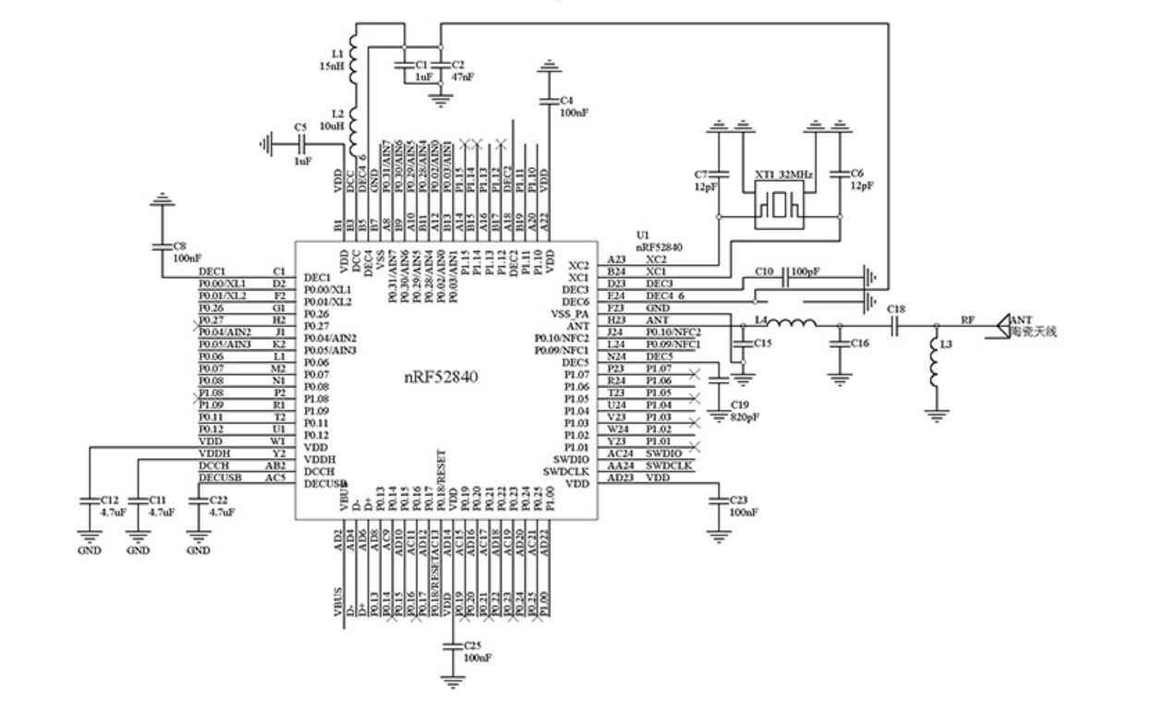

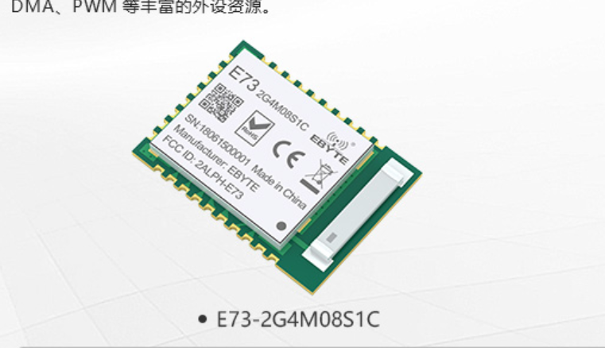

ble_app_beacon with inv_sqrt()

code
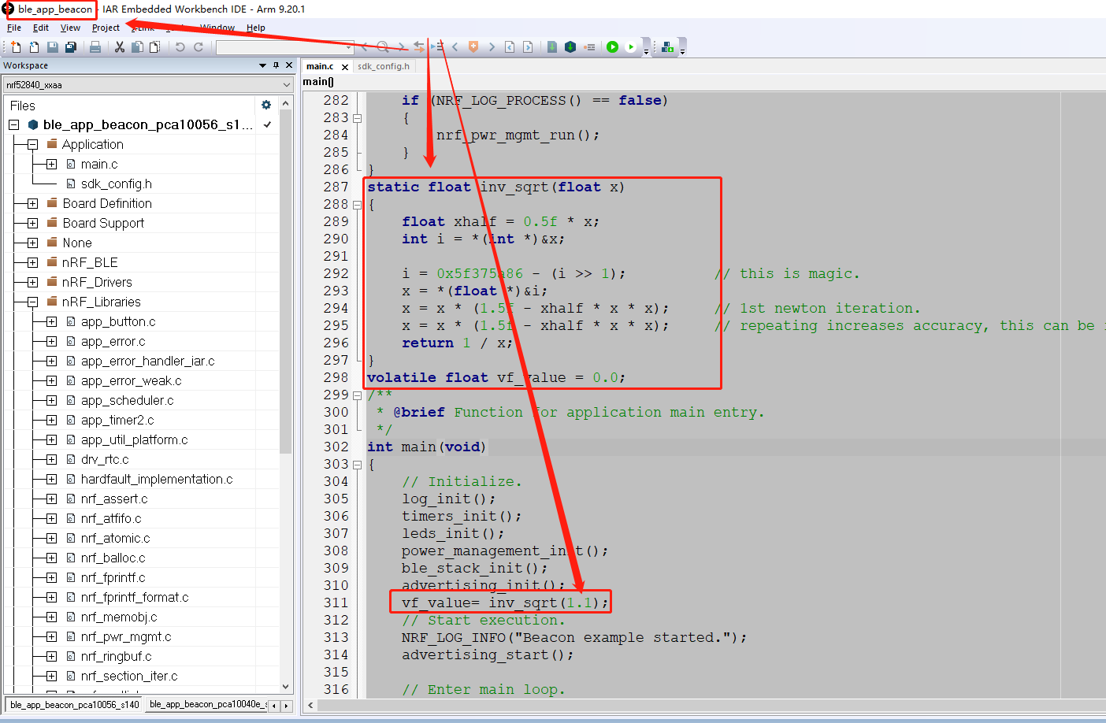

static float inv_sqrt(float x)
{
float xhalf = 0.5f * x;
int i = *(int *)&x;

i = 0x5f375a86 - (i >> 1); // this is magic.
x = *(float *)&i;
x = x * (1.5f - xhalf * x * x); // 1st newton iteration.
x = x * (1.5f - xhalf * x * x); // repeating increases accuracy, this can be remove.
return 1 / x;
}
volatile float vf_value = 0.0;
/**
* @brief Function for application main entry.
*/
int main(void)
{
// Initialize.
log_init();
timers_init();
leds_init();
power_management_init();
ble_stack_init();
advertising_init();
vf_value= inv_sqrt(1.1);
// Start execution.
NRF_LOG_INFO("Beacon example started.");
advertising_start();

// Enter main loop.
for (;; )
{
idle_state_handle();
}
}

Power
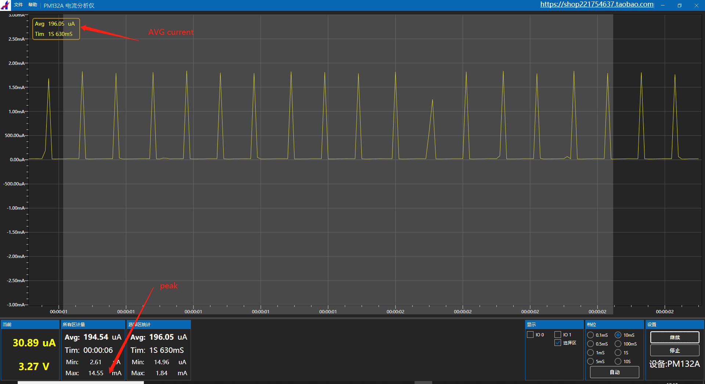

ble_app_hrs_freertos without inv_sqrt()

code
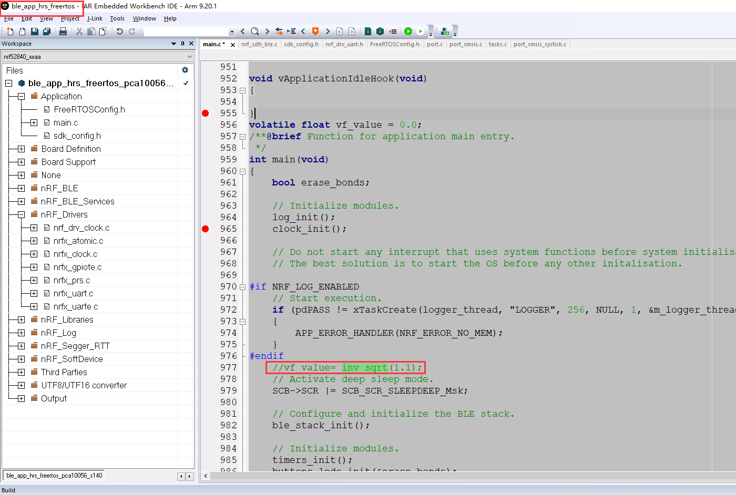
static float inv_sqrt(float x)
{
float xhalf = 0.5f * x;

int i = *(int *)&x;

i = 0x5f375a86 - (i >> 1); // this is magic.
x = *(float *)&i;

x = x * (1.5f - xhalf * x * x); // 1st newton iteration.
x = x * (1.5f - xhalf * x * x); // repeating increases accuracy, this can be remove.
return 1/x;
}

void vApplicationIdleHook(void)
{

}
volatile float vf_value = 0.0;
/**@brief Function for application main entry.
*/
int main(void)
{
bool erase_bonds;

// Initialize modules.
log_init();
clock_init();

// Do not start any interrupt that uses system functions before system initialisation.
// The best solution is to start the OS before any other initalisation.

#if NRF_LOG_ENABLED
// Start execution.
if (pdPASS != xTaskCreate(logger_thread, "LOGGER", 256, NULL, 1, &m_logger_thread))
{
APP_ERROR_HANDLER(NRF_ERROR_NO_MEM);
}
#endif
//vf_value= inv_sqrt(1.1);
// Activate deep sleep mode.
SCB->SCR |= SCB_SCR_SLEEPDEEP_Msk;

// Configure and initialize the BLE stack.
ble_stack_init();

// Initialize modules.
timers_init();
buttons_leds_init(&erase_bonds);
gap_params_init();
gatt_init();
advertising_init();
services_init();
sensor_simulator_init();
conn_params_init();
peer_manager_init();
application_timers_start();

// Create a FreeRTOS task for the BLE stack.
// The task will run advertising_start() before entering its loop.
nrf_sdh_freertos_init(advertising_start, &erase_bonds);

NRF_LOG_INFO("HRS FreeRTOS example started.");
// Start FreeRTOS scheduler.
vTaskStartScheduler();

for (;;)
{
APP_ERROR_HANDLER(NRF_ERROR_FORBIDDEN);
}
}

Power
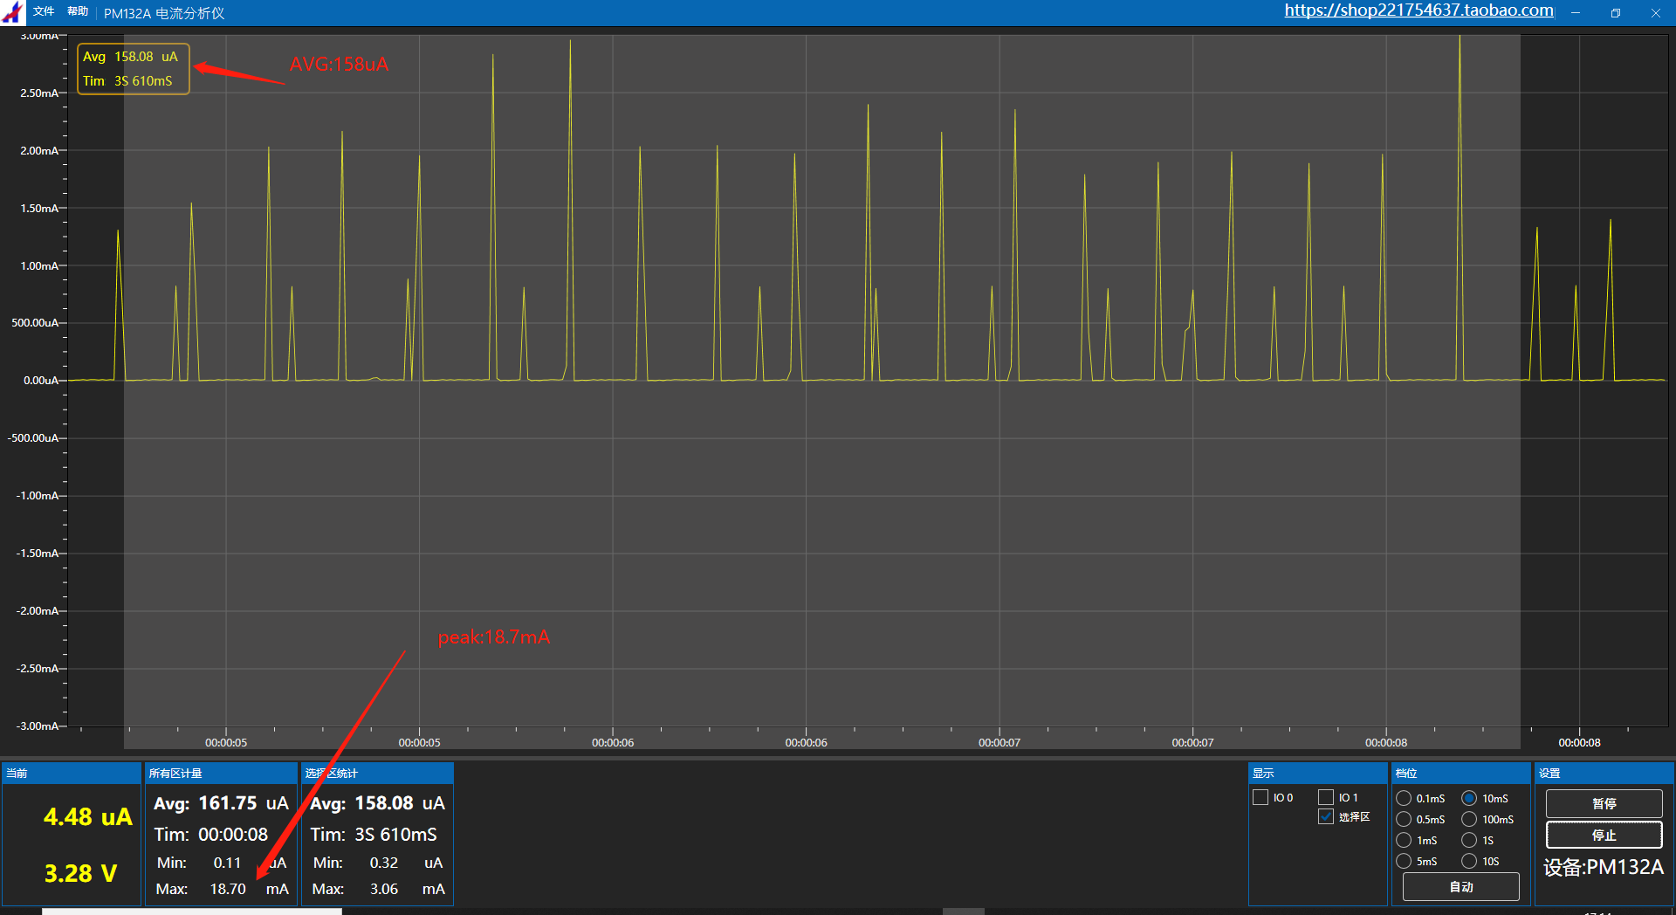

ble_app_hrs_freertos with inv_sqrt()

code
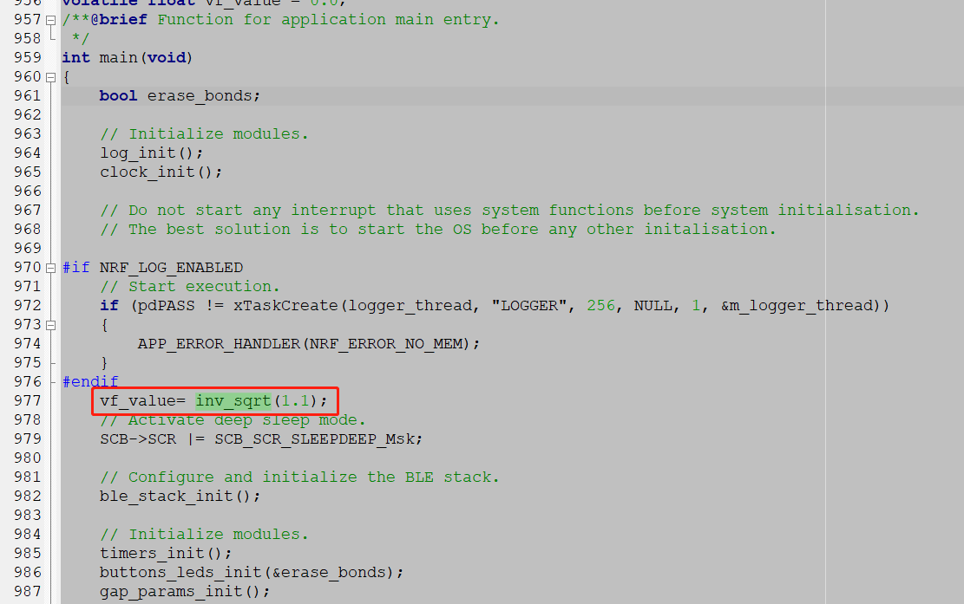

/**@brief Function for initializing the clock.
*/
static void clock_init(void)
{
ret_code_t err_code = nrf_drv_clock_init();
APP_ERROR_CHECK(err_code);
}
static float inv_sqrt(float x)
{
float xhalf = 0.5f * x;

int i = *(int *)&x;

i = 0x5f375a86 - (i >> 1); // this is magic.
x = *(float *)&i;

x = x * (1.5f - xhalf * x * x); // 1st newton iteration.
x = x * (1.5f - xhalf * x * x); // repeating increases accuracy, this can be remove.
return 1/x;
}

void vApplicationIdleHook(void)
{

}
volatile float vf_value = 0.0;
/**@brief Function for application main entry.
*/
int main(void)
{
bool erase_bonds;

// Initialize modules.
log_init();
clock_init();

// Do not start any interrupt that uses system functions before system initialisation.
// The best solution is to start the OS before any other initalisation.

#if NRF_LOG_ENABLED
// Start execution.
if (pdPASS != xTaskCreate(logger_thread, "LOGGER", 256, NULL, 1, &m_logger_thread))
{
APP_ERROR_HANDLER(NRF_ERROR_NO_MEM);
}
#endif
vf_value= inv_sqrt(1.1);
// Activate deep sleep mode.
SCB->SCR |= SCB_SCR_SLEEPDEEP_Msk;

// Configure and initialize the BLE stack.
ble_stack_init();

// Initialize modules.
timers_init();
buttons_leds_init(&erase_bonds);
gap_params_init();
gatt_init();
advertising_init();
services_init();
sensor_simulator_init();
conn_params_init();
peer_manager_init();
application_timers_start();

// Create a FreeRTOS task for the BLE stack.
// The task will run advertising_start() before entering its loop.
nrf_sdh_freertos_init(advertising_start, &erase_bonds);

NRF_LOG_INFO("HRS FreeRTOS example started.");
// Start FreeRTOS scheduler.
vTaskStartScheduler();

for (;;)
{
APP_ERROR_HANDLER(NRF_ERROR_FORBIDDEN);
}
}

Power
