Hardware (HW)
- BMD 350 evaluation board, equivalent to PCA10040

Software
- nRF5 SDK 12.0
- SoftDevice: s132_nrf52_3.0.0_softdevice.hex
- Bootloader (BL): nRF5_SDK_12.0.0_12f24da\examples\dfu\bootloader_secure None debug version
- Firmware application (FA): nRF5_SDK_12.0.0_12f24da\examples\ble_peripheral\experimental_ble_app_buttonless_dfu

Action
- Use nRFStudio to flash SoftDevice into HW
- Use Keil to compile FA and flash into HW

UART Log Message
SDH:INFO:sd_ble_enable: RAM START at 0x20002128
:INFO:running nrf_dfu_settings_init
:INFO:!!!!!!!!!!!!!!! Resetting bootloader settings !!!!!!!!!!!
:INFO:Erasing old settings at: 0x0007f000
:INFO:Erasing: 0x0007f000, num: 1
:INFO:Writing 0x00000057 words
:INFO:Writing settings...

In Android “nRF Toolbox”, find device “Nordic_Template”
- Use Keil to compile bootloader and flash into HW

UART Log Message
SDH:INFO:sd_ble_enable: RAM START at 0x20002128
:INFO:running nrf_dfu_settings_init

HW LED1 and LED3 both on
In Android “nRF Toolbox”, find device “DfuTarg”
- Follow the blog to generate application zip file (app_dfu_package.zip) for “experimental_ble_app_buttonless_dfu”
- Use Android “nRF Toolbox” to flash zip file to HW device. Success
- Device Reset
- Use “nRF Connect” scan to find “Nordic_Template”, DFU is discovered

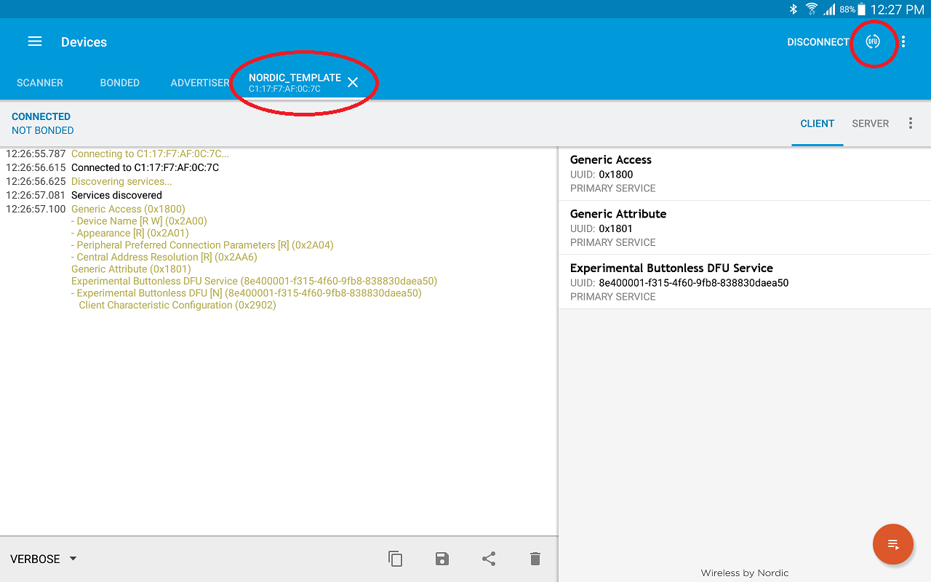

- Click DFU to start to flash app_dfu_package.zip, both “nRF Connect” and HW hang at “Starting Bootloader”.
