Hi Simon,

To summarize:

I’m working with your ble_app_rscs example. I’m aiming for BLE_GAP_ADV_TYPE_EXTENDED_NONCONNECTABLE_NONSCANNABLE_UNDIRECTED mode.

I have modified this example as follows:

1. Device advertises indefinitely
2. I’m not advertising any services, instead I’ve added manufactured specific data (see below)

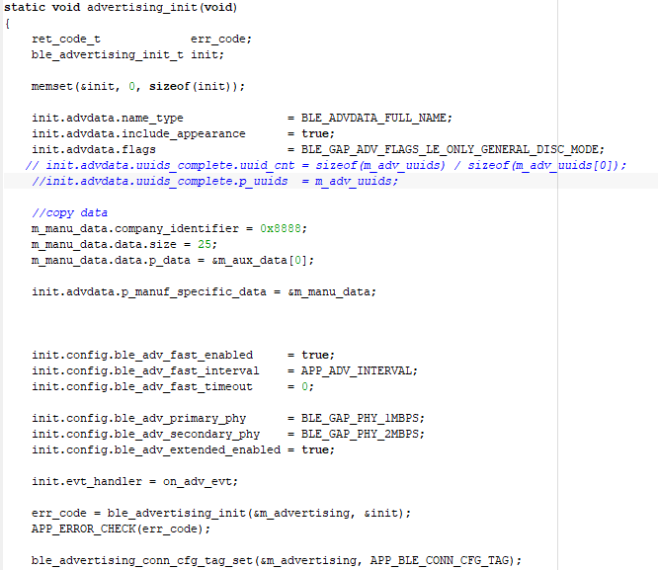

1. 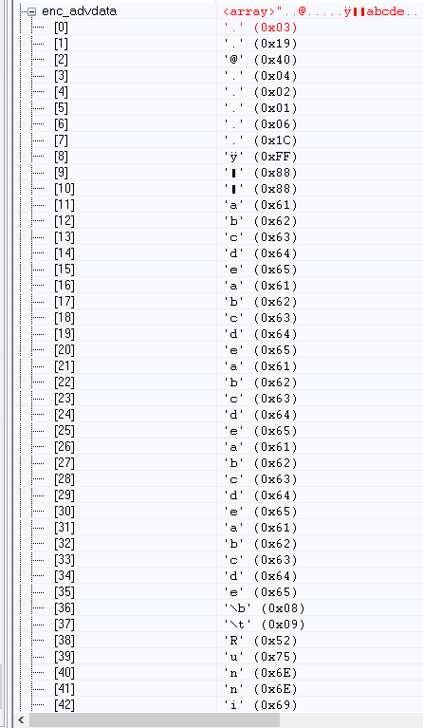m_advertising.enc_advdata array includes my data (a,b,c,d,e.. etc.) and the name of the device changed to Running. (see snapshot from the debugger)
2. On my BLE sniffer I’m expecting to see three ADV_EXT_IND frames, followed by AUX_ADV_IND, which should contain the data.

Instead The message sequence chart shows only ADV_EXT_IND frames

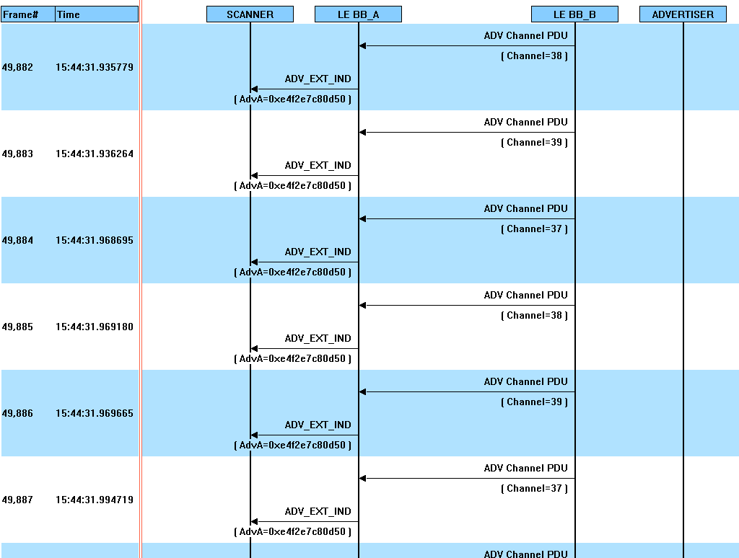

The view of the channels proves that no data is being advertised, you can see only primary advertising channels being used.

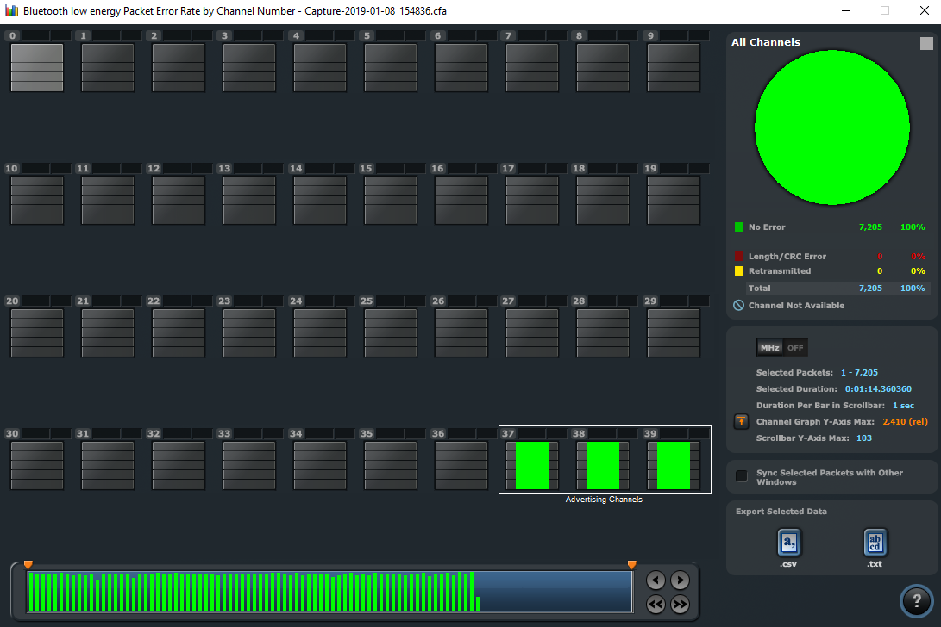

The ADV_EXT_IND frame correctly shows Extended Header and LE ADV.

Concluding, I’m still not sure how to send data in extended advertising, unconnected and non-scannable, undirected mode. Is it possible with SoftDevice version 6.1 at all?