- Contact Information

Company name: | Wuhan Qiwu Technology
Company address: | ADD: 3 / F, Creative workshop, No.04, District D, Creative world, No.16 Yezhihu West Road, Hongshan District, Wuhan City, Hubei Province,PRC(China)
Contact person name: | Chen junjie
- Position: | SQE
- E-mail address: | chenjunjie@igpsport.com
- Telephone number: | 15927128006
Distributor: | Avnet

- Problem description

Nordic Semiconductor part number: | nRF52840-QIAA-R/NORDIC
Total Manufactured Volume: | NA
Failure rate: | NA

General impact assessment (tick one): | Impact on final application (tick one):
Low  Y High  Production Line Stopped | Performance reduction  Y Failing application  Other
Production stage of failure (tick one): | Process information (tick all that applies):
Preproduction  Volume production  Y Field Return | Pre-mount programming  Y On-board Programming

Detailed problem description and symptoms:
<Please provide as much information as possible – internal analysis reports etc.>
Failure description:
Four returned products after sale could not be turned on & charged normally. Preliminary analysis of disassembly showed that the MCU was damaged, and the MCU was cross-verified. Among them, 2PCS chips were broken down. Our company wanted to confirm the failure cause of this problem (open the cover of 4PCS chips).
Cross-verify to confirm it is a bad chip.

Best Regards

- Device information
Please provide information on all impacted date codes below
Trace code | Devices manufactured | Devices failed |  | Comments
<2204A0> | <> | <4> |  | nRF52840-QIAA-R
<2404AN> | <quantity> | <quantity> |  | nRF52840-QIAA-R
<2409BK> | <quantity> | <quantity> |  | nRF52840-QIAA-R
<2201ZM> | <quantity> | <quantity> |  | nRF52840-QIAA-R

Device marking information:
Providepictures of ICs showing marking information: | 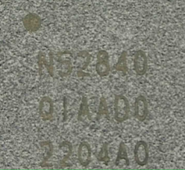 | 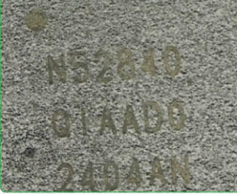 | 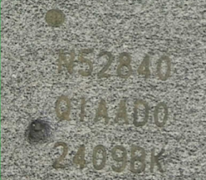 | 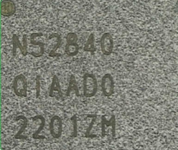

This document is Nordic Semiconductor’s Customer Failure Report (CFR), used to gather background information needed to complete an accurate and timely failure analysis.

Nordic Semiconductor may or may not request samples for further analysis work. This will be done by issuing a Return Material Authorization (RMA). By company policy, all returns not accompanied by a RMA will be sent back unopened.

