RF Att- 20dB; Expected Nom: 0; User Margin: 0; Trigger: Power; Input signal- LE; Advertiser
Field Board- SN: B1030125200810878
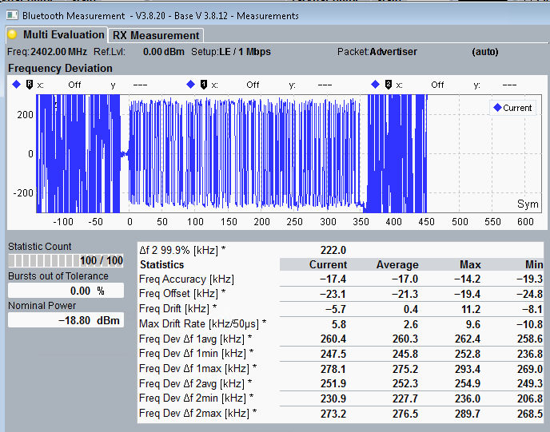
Field Board- SN: B1030125200724574
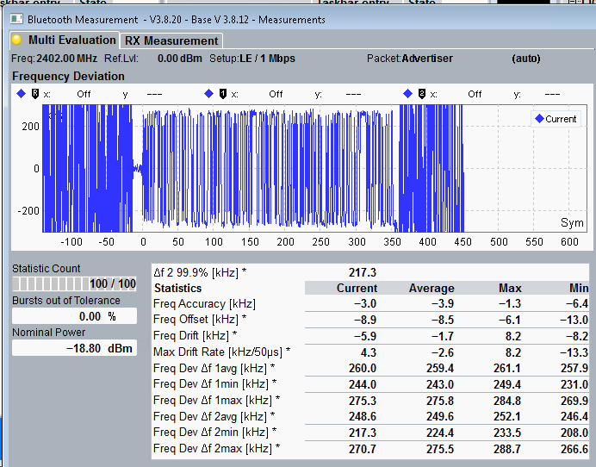
Field Board- SN: B1030125200724485
