* **How to Choose Load Capacitor values for oscillator?**



Figure 1 Reference Snap for Load capacitance calculation

**As Per TI Document Note:**

Reference Link “ <http://www.ti.com/lit/an/slla051/slla051.pdf>” Page no.7,Section 2.6.

-- 0.8 PF per centimeter capacitance considered for track capacitance calculation.

As per Above Equation,

-- Cpcb1 and Cpcb2 are capacitance formed by Track Length of board.

-- Cpin is Capacitance of Physical pin of device.

# 

Figure 2 32.768 Khz Oscillator Parameters

# As Per Above Figure recommended Load Capacitance (CL) Values is 12.5pF.

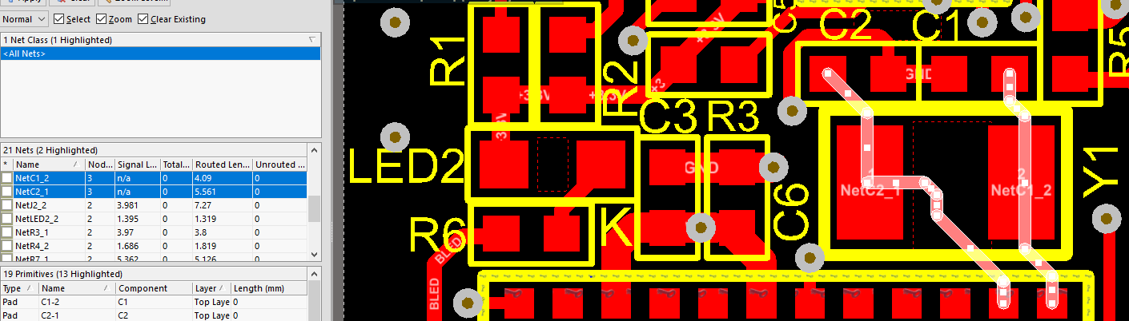

Figure 3 Board Track Length

# Considering Design was implemented with 22pF (C1=C2=22pF).

# As Per Equation indicated in Figure 1.

# CL= ((C1’ X C2’) / (C1’ + C2’))

Where,

# C1’= C1 + Cpcb1 + Cpin

C2’= C2 + Cpcb2 + Cpin

As per Above Fig.3 & Fig.4

C1’= 22pF + (0.8 X 0.40 ) + 4pF

C2’= 22pF + (0.8 X 0.55) + 4pF

# So,

# C1’= 22 + 0.32 + 4

# C2’= 22 + 0.44 + 4

# C1’ = 26.32

# C2’ = 26.44

# Final Calculation

# CL= ((C1’ X C2’) / (C1’ + C2’))

# CL = ((26.32 X 26.44) / (26.32 + 26.44)

# **CL= 13.18 pF which is near Equal to 12.5 pF.**