How to modify the S110 based DFU to work with the S310

- Include the S310 SoftDevice header files instead of the S110 headers:
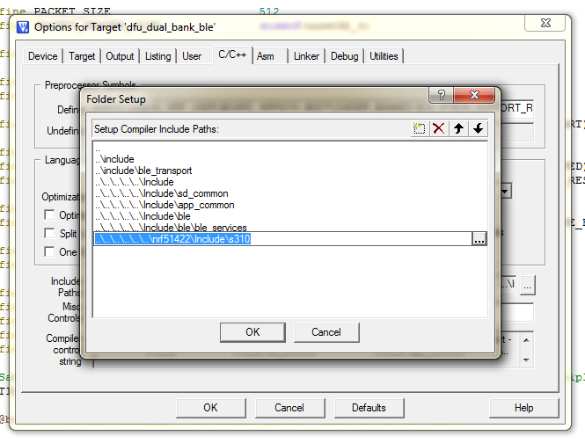
- Set the CODE_REGION_1_START define in dfu_types.h to 0x20000:
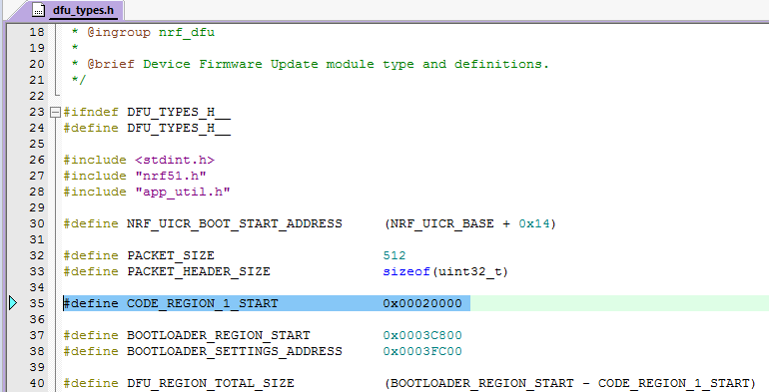
- Change the RAM allocation in the Keil settings to 0x20002400/0x1C00:
