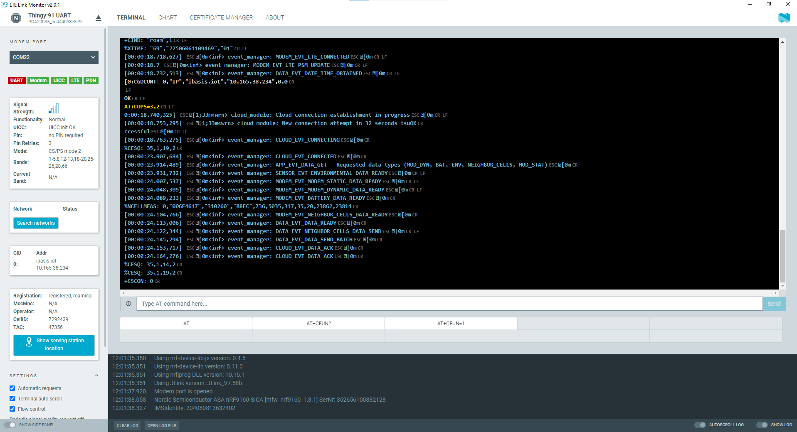
[00:00:00.232,208]

[0m<inf> event_manager: DATA_EVT_CONFIG_INIT

[0m

[00:00:00.238,739]

[0m<inf> event_manager: APP_EVT_ACTIVITY_DETECTION_DISABLE

[0m

[00:00:00.246,612]

[0m<inf> event_manager: MODEM_EVT_INITIALIZED

[0m

AT+CFUN?

[00:00:00.315,704]

[0m<inf> event_manager: MODEM_EVT_LTE_CONNECTING

[0m

+CFUN: 1

OK

AT+CGSN=1

+CGSN: "352656100882128"

OK

AT+CGMI

Nordic Semiconductor ASA

OK

AT+CGMM

nRF9160-SICA

OK

AT+CGMR

mfw_nrf9160_1.3.1

OK

AT+CEMODE?

+CEMODE: 2

OK

AT%XCBAND=?

%XCBAND: (1,2,3,4,5,8,12,13,18,19,20,25,26,28,66)

OK

AT+CMEE?

+CMEE: 0

OK

AT+CMEE=1

OK

AT+CNEC?

+CNEC: 0

OK

AT+CNEC=24

OK

AT+CGEREP?

+CGEREP: 0,0

OK

AT+CGDCONT?

OK

AT+CGACT?

OK

AT+CGEREP=1

OK

AT+CIND=1,1,1

OK

AT+CEREG=5

OK

AT+CEREG?

+CEREG: 5,4

OK

AT%CESQ=1

OK

AT+CESQ

+CESQ: 99,99,255,255,255,255

OK

AT%XSIM=1

OK

AT%XSIM?

%XSIM: 1

OK

AT+CPIN?

+CPIN: READY

OK

AT+CPINR="SIM PIN"

+CPINR: "SIM PIN",3

OK

AT+CIMI

204080813632402

OK

%CESQ: 43,2,14,2

+CEREG: 2,"FA08","03D31702",7

[00:00:09.130,096]

[0m<inf> event_manager: MODEM_EVT_LTE_DISCONNECTED

[0m

[00:00:09.137,237]

[0m<inf> event_manager: MODEM_EVT_LTE_CELL_UPDATE

[0m

+CSCON: 1

+CNEC_EMM: 15

+CEREG: 2,"FA08","03D31702",7,0,15

+CSCON: 0

%CESQ: 255,0,255,0

+CEREG: 2

[00:00:12.539,001]

[0m<inf> event_manager: MODEM_EVT_LTE_CELL_UPDATE

[0m

%CESQ: 33,1,18,2

+CEREG: 2,"B8FC","006F4617",7

[00:00:14.209,777]

[0m<inf> event_manager: MODEM_EVT_LTE_CELL_UPDATE

[0m

+CSCON: 1

%CESQ: 35,1,13,1

%CESQ: 35,1,19,2

%CESQ: 35,1,14,2

+CGEV: ME PDN ACT 0,0

+CNEC_ESM: 50,0

+CEREG: 5,"B8FC","006F4617",7,,,"11100000","11100000"

AT+CGDCONT?

+CIND: "service",1

+CIND: "roam",1

%XTIME: "69","22506061109469","01"

[00:00:18.718,627]

[0m<inf> event_manager: MODEM_EVT_LTE_CONNECTED

[0m

[00:00:18.7

[0m<inf> event_manager: MODEM_EVT_LTE_PSM_UPDATE

[0m

[00:00:18.732,513]

[0m<inf> event_manager: DATA_EVT_DATE_TIME_OBTAINED

[0m

[0+CGDCONT: 0,"IP","ibasis.iot","10.165.38.234",0,0

OK

AT+COPS=3,2

0:00:18.740,325]

[1;33m<wrn> cloud_module: Cloud connection establishment in progress

[0m

[00:00:18.753,295]

[1;33m<wrn> cloud_module: New connection attempt in 32 seconds isuOK

ccessful

[0m

[00:00:18.763,275]

[0m<inf> event_manager: CLOUD_EVT_CONNECTING

[0m

%CESQ: 35,1,19,2

[00:00:23.907,684]

[0m<inf> event_manager: CLOUD_EVT_CONNECTED

[0m

[00:00:23.914,489]

[0m<inf> event_manager: APP_EVT_DATA_GET - Requested data types (MOD_DYN, BAT, ENV, NEIGHBOR_CELLS, MOD_STAT)

[0m

[00:00:23.931,732]

[0m<inf> event_manager: SENSOR_EVT_ENVIRONMENTAL_DATA_READY

[0m

[00:00:24.007,537]

[0m<inf> event_manager: MODEM_EVT_MODEM_STATIC_DATA_READY

[0m

[00:00:24.048,309]

[0m<inf> event_manager: MODEM_EVT_MODEM_DYNAMIC_DATA_READY

[0m

[00:00:24.089,233]

[0m<inf> event_manager: MODEM_EVT_BATTERY_DATA_READY

[0m

%NCELLMEAS: 0,"006F4617","310260","B8FC",736,5035,317,35,20,23862,23814

[00:00:24.104,766]

[0m<inf> event_manager: MODEM_EVT_NEIGHBOR_CELLS_DATA_READY

[0m

[00:00:24.113,006]

[0m<inf> event_manager: DATA_EVT_DATA_READY

[0m

[00:00:24.122,344]

[0m<inf> event_manager: DATA_EVT_NEIGHBOR_CELLS_DATA_SEND

[0m

[00:00:24.145,294]

[0m<inf> event_manager: DATA_EVT_DATA_SEND_BATCH

[0m

[00:00:24.153,717]

[0m<inf> event_manager: CLOUD_EVT_DATA_ACK

[0m

[00:00:24.164,276]

[0m<inf> event_manager: CLOUD_EVT_DATA_ACK

[0m

%CESQ: 35,1,14,2

%CESQ: 35,1,19,2

+CSCON: 0

%CESQ: 36,1,12,1

%CESQ: 36,1,17,2

