NRF5340 Application core: \TOOLCHAIN\v1.8.0\nrf\samples\nrf5340\empty_app_core
NRF5340 Network core: \TOOLCHAIN\v1.8.0\zephyr\samples\bluetooth\hci_pwr_ctrl

- Build by SES => Work. Can change TX power at NRF5340.
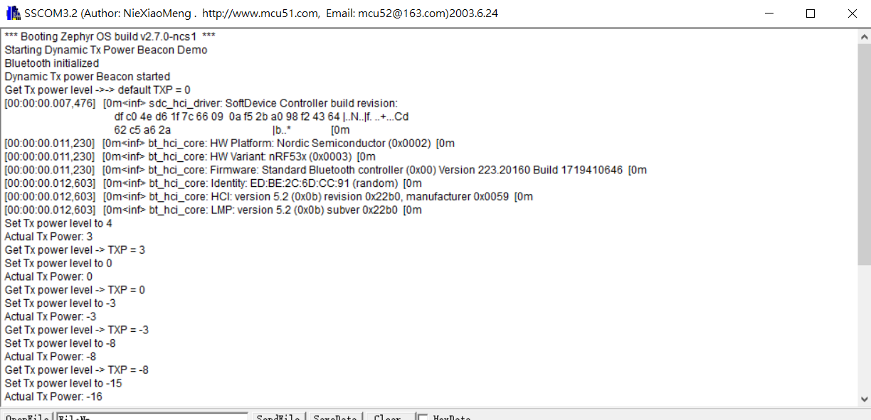
- Build by West => Work. Can change TX power at NRF5340.
