1. Create folder:

C:\nRF5_SDK_16.0.0_98a08e2\examples\ble_peripheral\ble_app_buttonless_dfu_spout\pca10056\s140\ses\Test_dfu\Test_dfuV16

I used the private and public keys that I generated before:

1. **~~Generate own private key1 in Test_dfu1: open dos command screen and do:~~**

~~nrfutil.exe keys generate private1.key~~

1. **~~Generate public key based on your private key.~~**

~~nrfutil keys display --key pk --format code private1.key --out_file public_key1.c~~

~~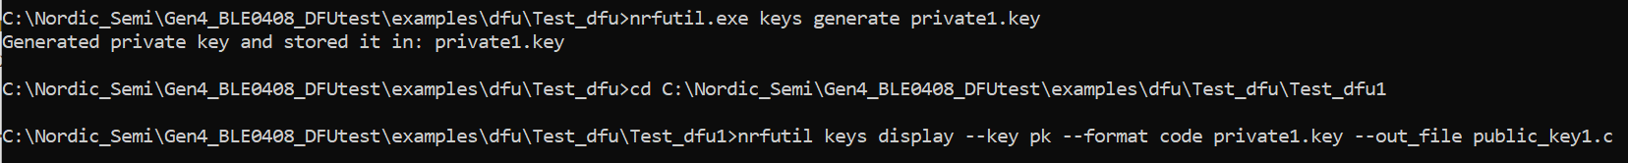~~

1. **~~Compile the uECC library.~~**

~~uECC library is needed for the bootloader to decrypt the signature. uECC is an external library and have to be downloaded from github here. Note: there is a license requirement comes with it.~~

~~You have to clone/download the library to the SDK folder: SDKFolder\external\micro-ecc\micro-ecc . It should look like this:~~

~~Next step, inside SDKFolder\external\micro-ecc\ choose the IDE and compiler that you want to use to build the bootloader. In my case I chose SDKFolder\external\micro-ecc\nrf52_keil\armgcc and type make to start building uECC.~~

1. **Build the secure buttonless bootloader with dfu_public_key.c**

The bootloader is located at C:\nRF5_SDK_16.0.0_98a08e2\examples\dfu_spout\secure_bootloader\pca10056_s140_ble\ses

#define NRF_DFU_BLE_REQUIRES_BONDS 1 // Donald

#define NRF_SDH_BLE_SERVICE_CHANGED 1 // donald

Update include **dfu_public_key.c** and build project.

Build and Copy C:\nRF5_SDK_16.0.0_98a08e2\examples\dfu_spout\secure_bootloader\pca10056_s140_ble\ses\Output\Release\Exe\secure_bootloader_ble_s140_pca10056.hex to C:\nRF5_SDK_16.0.0_98a08e2\examples\ble_peripheral\ble_app_buttonless_dfu_spout\pca10056\s140\ses\Test_dfu\Test_dfuV16

1. **Copy softdevice.hex to Test_dfuV16 folder**

Open the folder C:\nRF5_SDK_16.0.0_98a08e2\components\softdevice\s140\hex, and copy the .hex file s140_nrf52_7.0.1_softdevice.hex to C:\nRF5_SDK_16.0.0_98a08e2\examples\ble_peripheral\ble_app_buttonless_dfu_spout\pca10056\s140\ses\Test_dfu\Test_dfuV16 folder.

1. **Build application and copy to Test_dfuV16 folder**

At folder: C:\nRF5_SDK_16.0.0_98a08e2\examples\ble_peripheral\ble_app_buttonless_dfu_spout\pca10056\s140\ses

#define NRF_DFU_BLE_BUTTONLESS_SUPPORTS_BONDS 1 // donald

Create an application, ble_app_buttonless_dfu, and copy the ble_app_buttonless_dfu_pca10056_s140.hex file as you did for the bootloader to your C:\nRF5_SDK_16.0.0_98a08e2\examples\ble_peripheral\ble_app_buttonless_dfu_spout\pca10056\s140\ses\Test_dfu\Test_dfuV16

1. **Generate settings page in** C:\nRF5_SDK_16.0.0_98a08e2\examples\ble_peripheral\ble_app_buttonless_dfu_spout\pca10056\s140\ses\Test_dfu\Test_dfuV16 folder

**nrfutil settings generate --family NRF52840 --application** ble_app_buttonless_dfu_pca10056_s140.hex **--application-version 1 --bootloader-version 1 --bl-settings-version 1 settings1.hex**

The output looks like this:

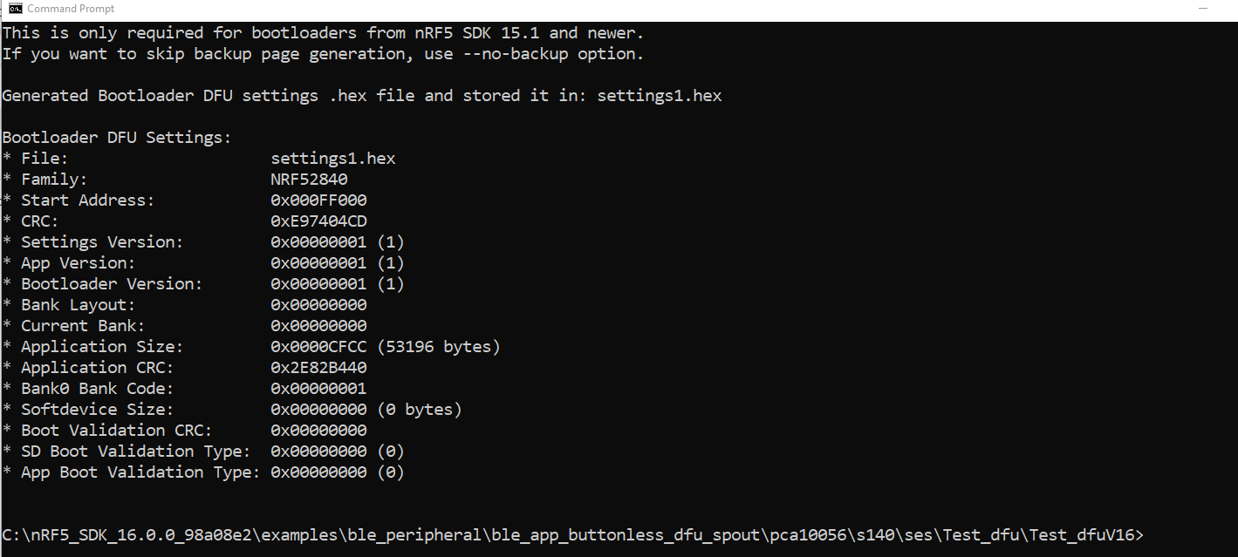

1. **Merge the setting1 with bootloader1**

Merge the **settings1.hex** and **secure_bootloader_ble_s140_pca10056.hex** together by running this command in **cmd** in your dfu folder:

mergehex.exe --merge settings1.hex secure_bootloader_ble_s140_pca10056.hex --output settings1_and_bootloader1.hex

The output looks like this:

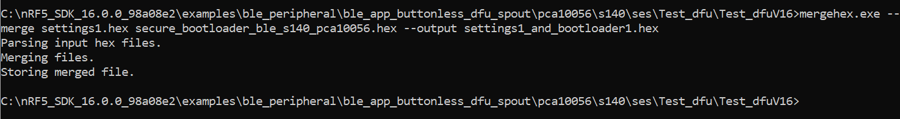

1. **Merge the DFU packet and build app_buttonless1.zip**

Generate the DFU packet by running this command in **cmd** in your dfu folder:

nrfutil pkg generate --hw-version 52 --application-version 1 --application ble_app_buttonless_dfu_pca10056_s140.hex --sd-req 0xA9 --key-file private1.key app_buttonless1.zip

The output looks like this:



1. **Programming bootloader**

Open the dfu folder in **cmd**, and write the commands:

nrfjprog.exe -e

nrfjprog.exe --program s140_nrf52_7.0.1_softdevice.hex --verify

nrfjprog.exe --program settings1_and_bootloader1.hex --verify -r

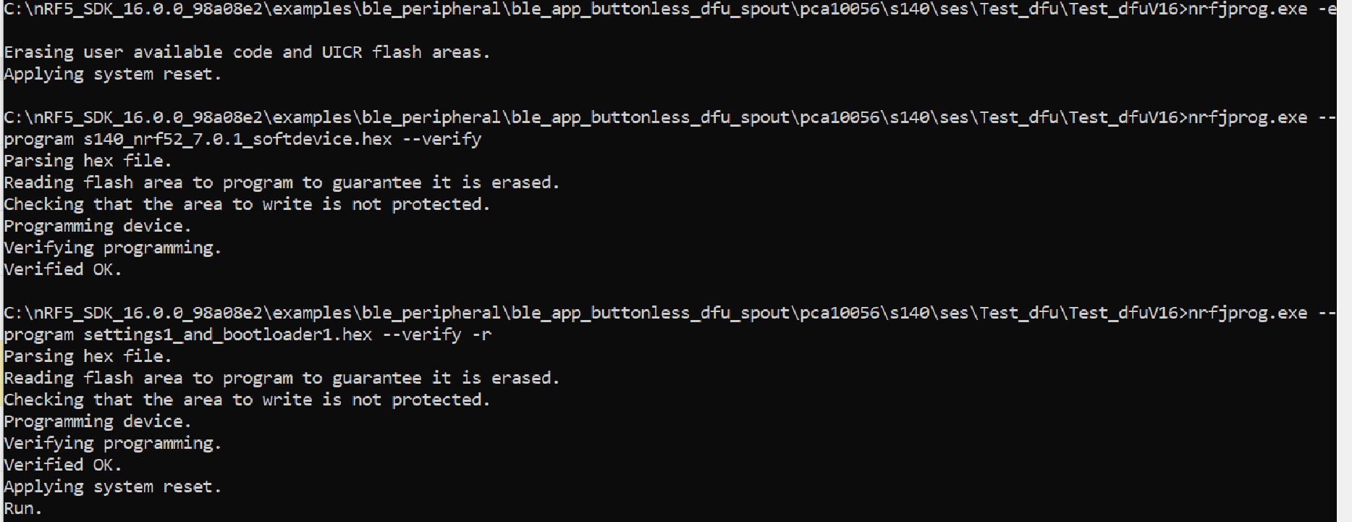

1. **Start nRF Connect; NO DfuTarg**

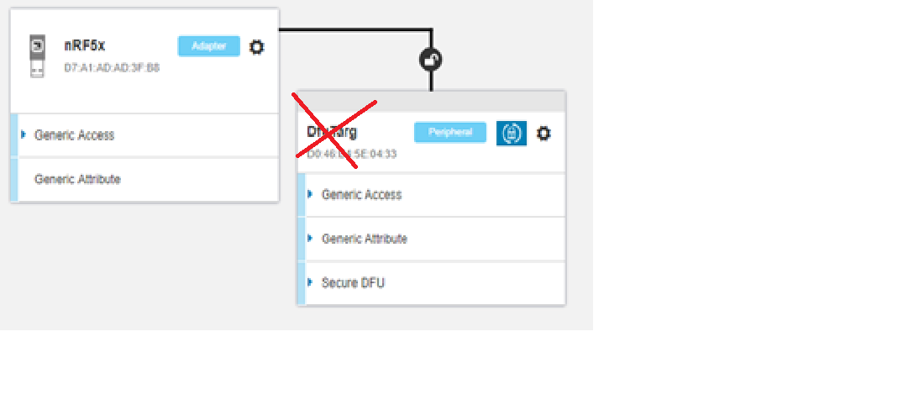

1. **The Nordic nRF52840-DK tas LED1 and LED2 both blinking**

