nRF52840 setup and comments,
1. "Can you please give some more information about what your project is doing when you are measuring the current and how you are measuring it? You say the device has joined the network, but is it performing any other actions while you are measuring the current consumption?
You can also check out our guide Measuring current, and I recommend reading the note further down on that page. Additionally, it is suggested to cut SB40 to put P22 in series with the load, as explained in Preparing the DK. You should also set SW6 to "nRF only"
- Our End product consist of 2 part, one is STM8 base board (as Master which is already developed) and second is nRF52840 (as Node). Both Master and Node interfaced using UART and GPIO. We are using 1 GPIO pin toggle between input and output. And UART to transfer and receive data from Node to Master and Master to Node.
- In this product, we are developing nRF52840(Node) part. Here in nRF part, we have enabled UART, TIMER and GPIO as explained in above point.
- Also, we write Zigbee commands to attributes and format in UART command and by toggling GPIO send the command to Master. And Master board contains push buttons to set temperature. nRF board read it and send data to gateway (here, gateway may be anything Alexa or deCONZ or Home assistant application. Gateway is not our part).
- After device joined network, we send read command to STM8 board to refresh the current data on STM8 board(Master board). Then stable no operation till any command from Zigbee or button press from STM8 board.
- Please check below image of our Radiator product push buttons and complete measuring setup.
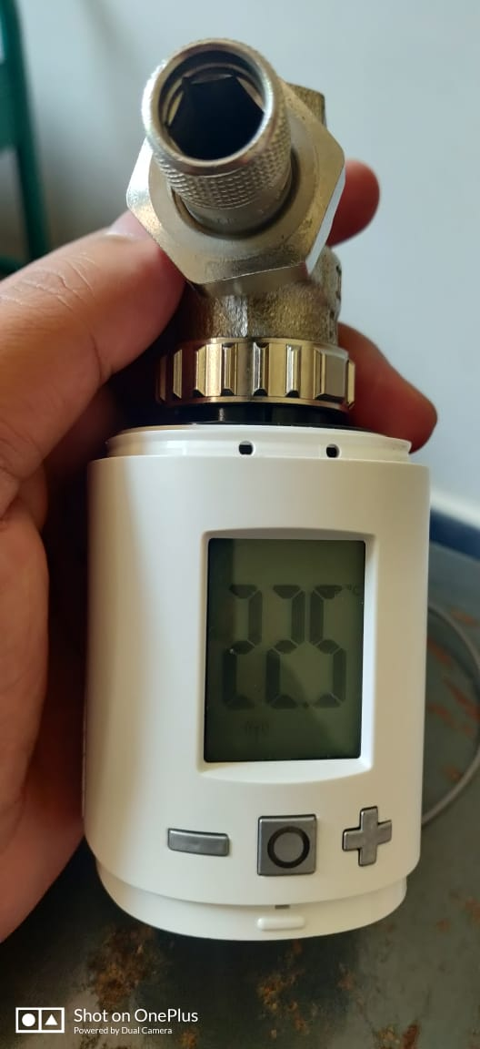
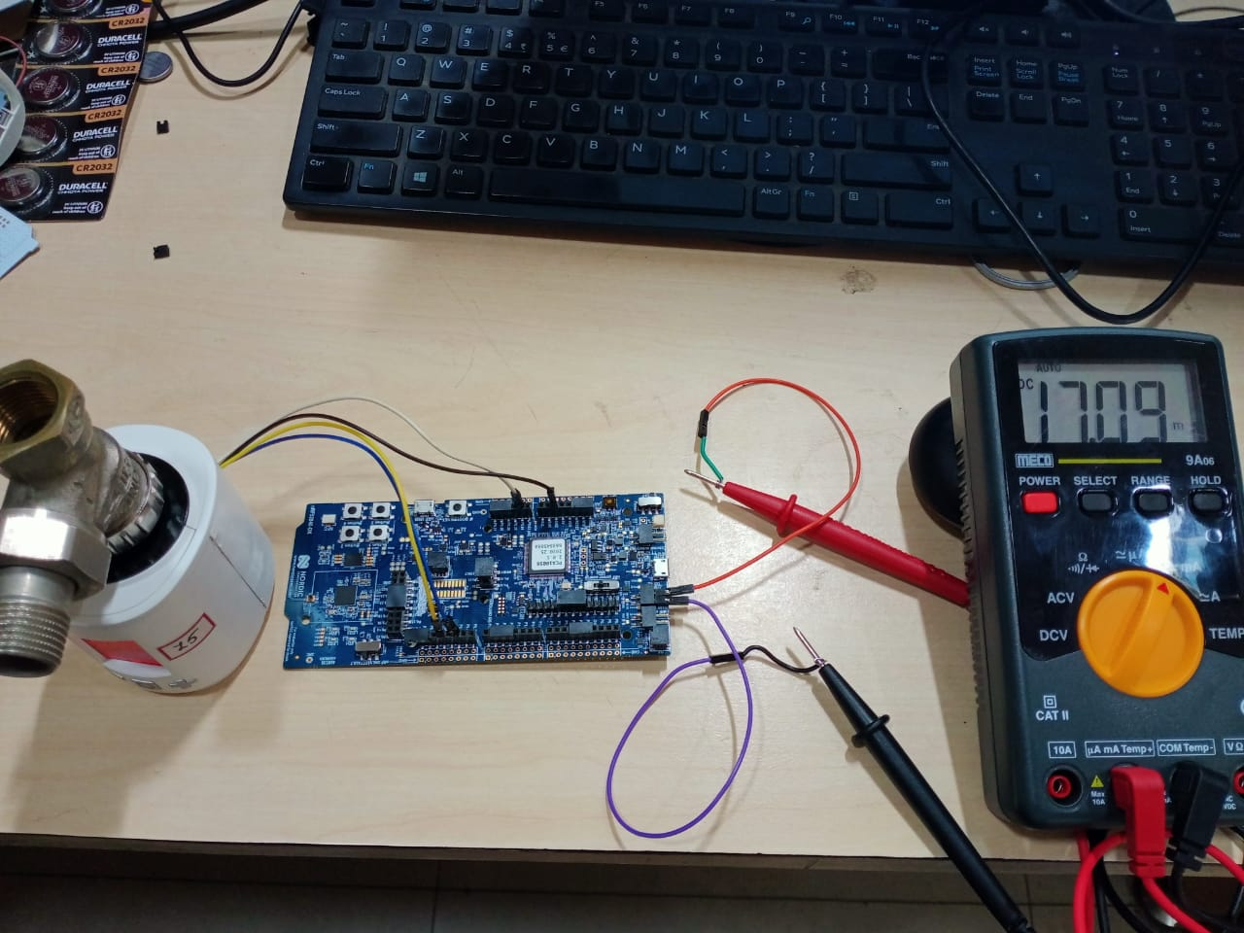
- We followed the steps from nrf52840 user guide to cut the SB40 and connect the multi meter to P22 as per document. And "You should also set SW6 to "nRF only"" this part was not mentioned in user guide so we kept in default only and tested current. Now I will test with this Configuration too.
- We are using coin cell to measure the current as per guide note. Before discovery we get current around 15mA and after discovery is done once stabled we get 1mA. And if any command exchange current again goes to 15mA and after completion stables for 1mA. While measuring current without enabling "SW6 to nRF only" I came across one observation that,. After discovery process done and device connect to gateway we get reading as 1mA but after 4 to 5min automatically dev-kit on board discover LED turn OFF. Also, we get same current reading as coin cell when we use USB to power up though it not recommended in guide docs.
2. "When performing current consumption tests earlier, our developers have managed to get sleep current consumption down to 1.6-3.3 µA, depending on the amount of RAM retention. This was when the device had joined and was not performing additional actions, but being in sleep mode. However, it is difficult to compare with your results without knowing more about your test setup."
- From one of the post from forum, I followed below lines to power down the unused ram section. As per my understand I enabled the below line in code to power down the unused ram. Let me know If I followed any wrong method here.
- Along with this I am working on to port the SDK4.1 power down unused ram function into SDK3.0 as per your suggestion. But I am attaching old logic because I have shared you current measured till last firmware.
- Please find the attached memory usage image and let me know what I did wrong in code power down ram.
- code part ram unused -
NRF_POWER->RAM[3].POWERCLR = 0x3;
NRF_POWER->RAM[4].POWERCLR = 0x3;
NRF_POWER->RAM[5].POWERCLR = 0x3;
NRF_POWER->RAM[6].POWERCLR = 0x3;
NRF_POWER->RAM[7].POWERCLR = 0x3;
NRF_POWER->RAM[8].POWERCLR = 0x3;
- memory image -
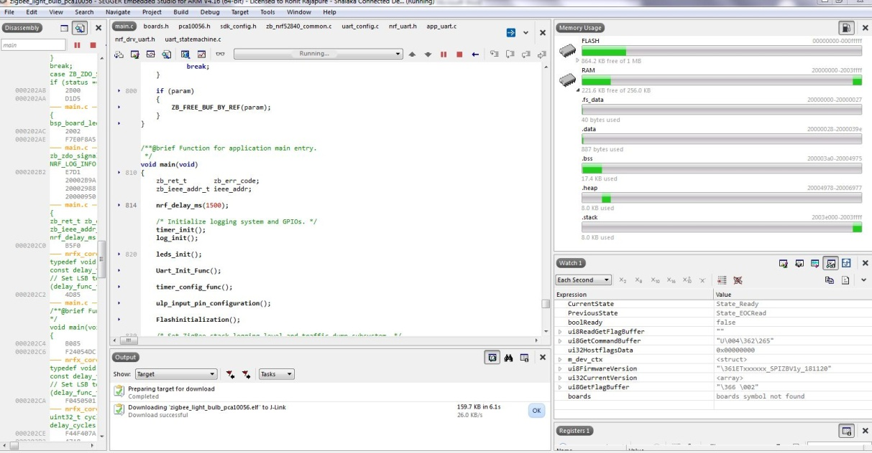
3. "If you want to get the lowest possible current consumption, you should use SED. You will not get lower current consumption when not using SED. The difference between SED and non sleepy devices is that with SED the radio is turned off and does not receive or send packets. This greatly reduces current consumption."
- Okay, I will follow the same.
4. " If you are using SED but does not see a significant impact on the current consumption, then it is possible the device does not go to sleep as it should, or that it wakes up very often."
- Yes, this might be possible. can you help me how identify whether the configuration is correct or not. To enable SED as per your suggestion I have referred the "multi sensor" example.
- Please find the attached main.c file of my project. Only thing is I have not used zb_sleep_set_threshold() function as it is not present in multi sensor example. So tested with minimum configuration. Let me know Effect and any changes I have missed to enable SED.

5. "Also, the current consumption in SED applications is further optimized in v4.1.0 of the SDK, so you it is very likely you would get a lower current consumption using that version""
- Okay, but as I said previously that I am unable to see some of the attributes and project completion pressure I am developing in SDK3.0 and still lot features pending. I have noted this point I will discuss your suggestion again with my higher team.

- Let me know your feedback on my points and correct me I am following any wrong steps here.

