Details:
- Soc: nRF5340 for development.
- SDK: nRFConnect SDK
- IDE: Segger Embedded Studio: running on Windows 64bit machine.
- Project objective: Data transfer and relay between nodes of BLE mesh network.
- Reference projects: light and light switch
- This reference project is derived as "Solution which contains multiple project"
- This is unlike "Solution with multiple groups of files in nRF5 and mesh SDK based project for nRF52832.
- Attached the picture of nRF5340 project using nRF connect SDK and nRF52832 project with mesh SDK.
- It looks like nRF5340 project is complex to customize to user need.
- hope that Project in nRF5340 != Group in nRF52832
- Programming Language: CPP

===
nRF5340 – Light Switch Project based on nRF Connect SDK
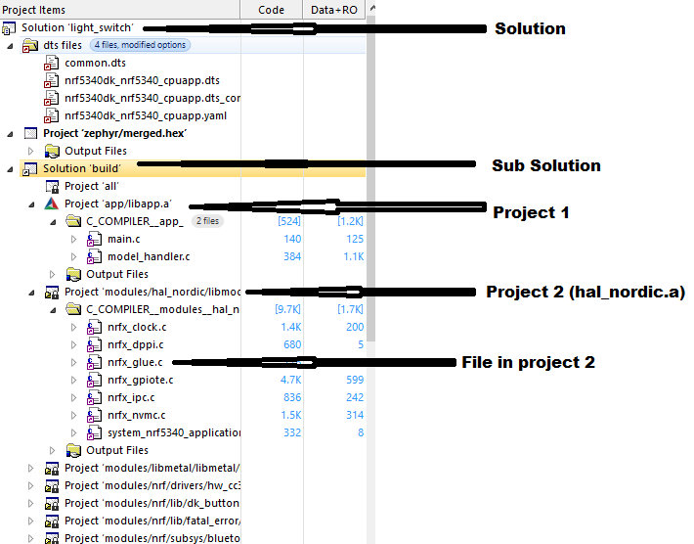

nRF52832 light switch project based on nRF5 and mesh SDK:
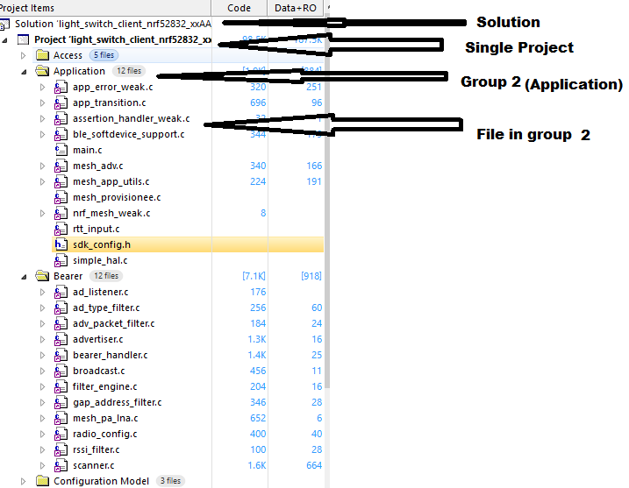

Please guide us on below points:
1.How to customize the project by integrating CPP files at app.a project?

