Bluetooth Specification Core: peripheral can suggest the anchor point by sending conn parameter update message
The Slave can suggest the anchor point by sending Connection parameter update request. And the Master decide the anchor point and notify slave by sending connection update req.
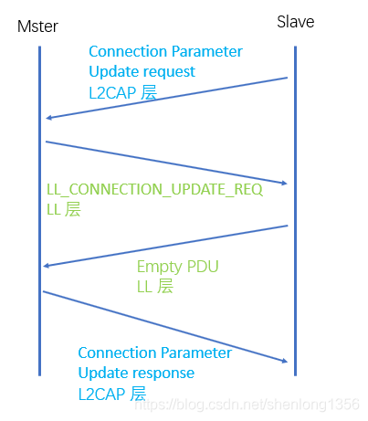
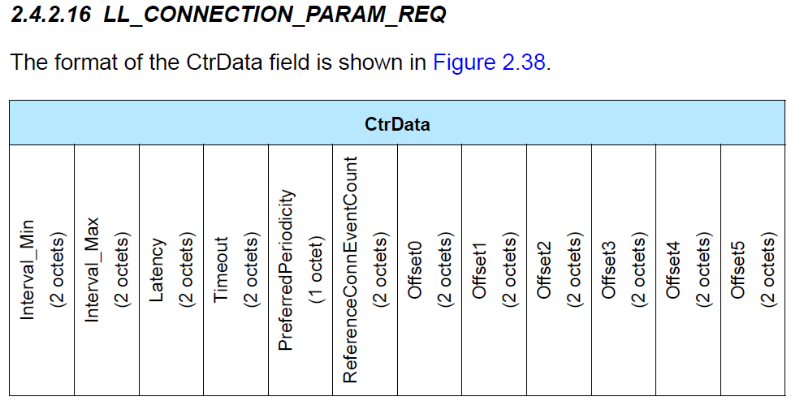
ReferenceConnEventCount define the referent point of anchor and Offset0-Offset5 define the off of the anchor according to the ReferenceConnEventCount.
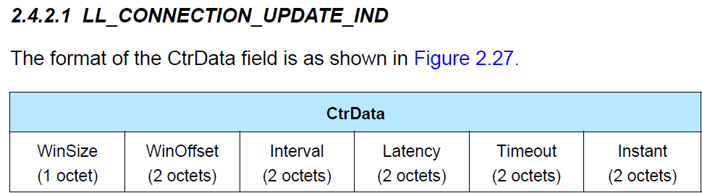
WinOffset and Instant decide the anchor point.

S140 SoftDevie specification: Peripheral link timing-events may collide with any other running role timing-events
The pic below is from SoftDevice Spec, chapter 15.6
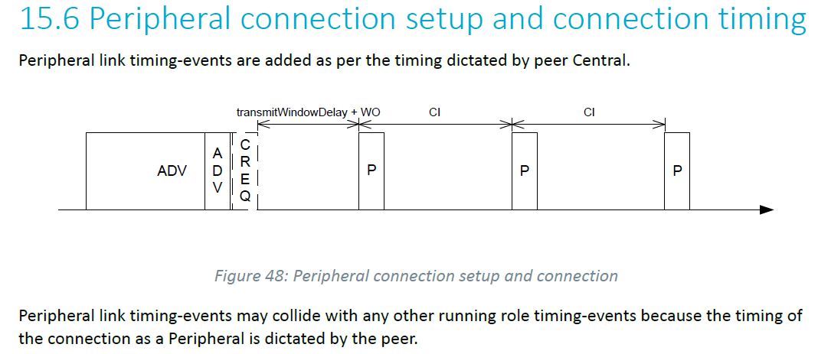
And Nordic have said in chapter 15.1 as below:
Peripheral role timing-events (peripheral link timing-event, advertiser/
broadcaster timing-event) and central role timing-events (central link timing-event, initiator/ scanner timing-event) are scheduled independently and so may occur at the same time and collide.
So If one nRF52840 connect two other nRF52840. The nRF52840 be a HUB(central and peripheral roles) will have more collisions than only be a Master(central roles), is it true?

Can SDK solve collisions by sending connection parameter update message?
In our device, We must have a HUB(central and peripheral roles), we found it will drop data, and it will be better when be master only.
So can HUB support scheduling the anchor point by sending connection parameter update message in your SDK?

