nRF9160 PSM current consumption test problem

**Hardware：**

nrf9160dk+current meter (Precision)

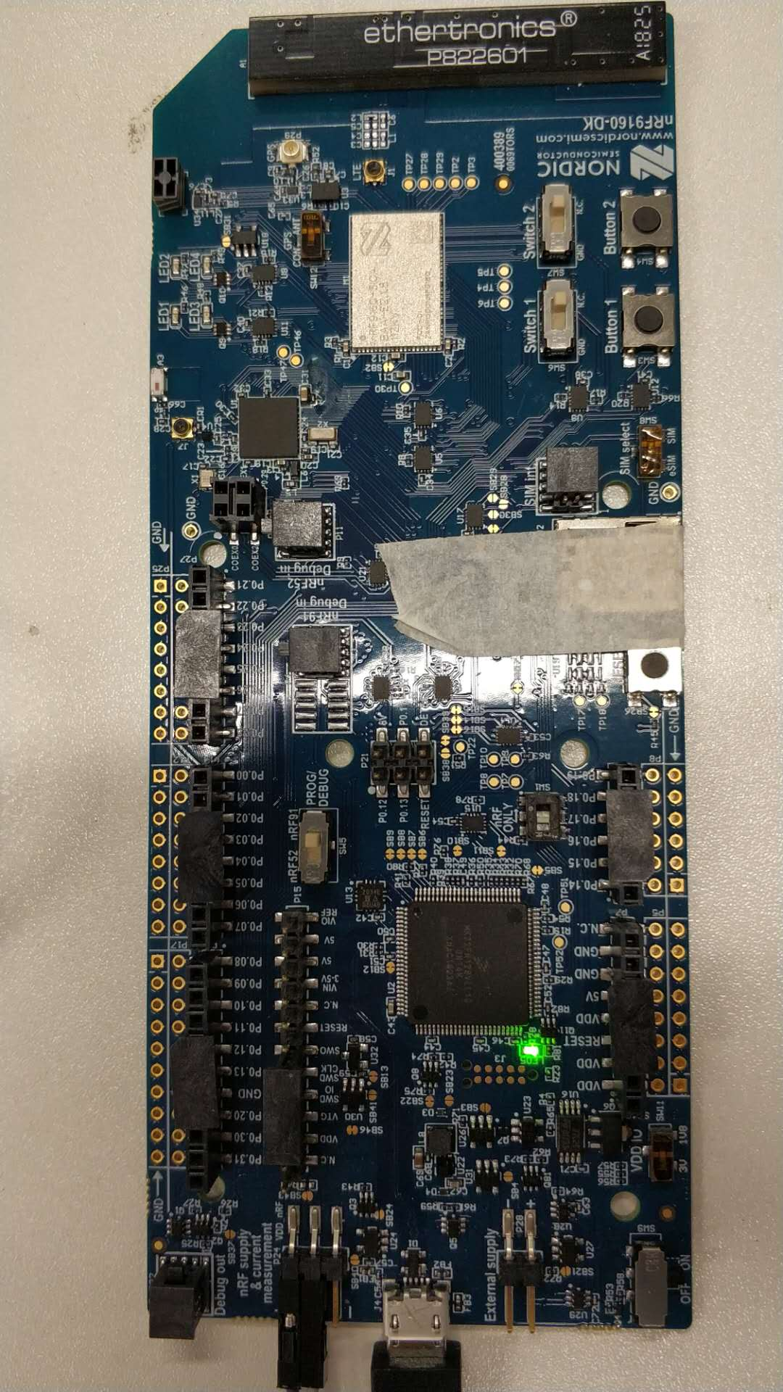

**Software：**

AP firmware：*nrf9160dk_at_client_2019-11-29_d3130d77.hex*

Modem firmware：*mfwnrf9160110*

**Test Methods：**

Follow the nRF9160_DK_User_Guide

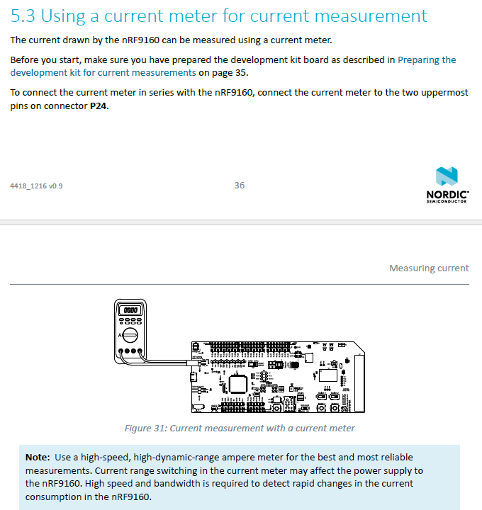

**LOG：**

2020-04-21T12:05:56.396Z INFO Application data folder: C:\Users\Q\AppData\Roaming\nrfconnect\pc-nrfconnect-linkmonitor

2020-04-21T12:05:56.482Z DEBUG App pc-nrfconnect-linkmonitor v1.1.1 official

2020-04-21T12:05:56.482Z DEBUG App path: C:\Users\Q\.nrfconnect-apps\node_modules\pc-nrfconnect-linkmonitor

2020-04-21T12:05:56.483Z DEBUG nRFConnect 3.3.1 is supported by the app (^3.2.0)

2020-04-21T12:05:56.483Z DEBUG nRFConnect path: C:\Users\Q\AppData\Local\Programs\nrfconnect\resources\app.asar

2020-04-21T12:05:56.483Z DEBUG HomeDir: C:\Users\Q

2020-04-21T12:05:56.483Z DEBUG TmpDir: C:\Users\Q\AppData\Local\Temp

2020-04-21T12:05:58.267Z INFO Modem port is opened

2020-04-21T12:05:58.273Z DEBUG modem >> AT+CFUN?\x0D\x0A

2020-04-21T12:05:58.302Z DEBUG modem << +CFUN: 0\x0D\x0A

2020-04-21T12:05:58.304Z DEBUG modem << OK\x0D\x0A

2020-04-21T12:06:00.578Z DEBUG modem >> AT+CFUN=1\x0D\x0A

2020-04-21T12:06:00.617Z DEBUG modem << OK\x0D\x0A

2020-04-21T12:06:01.793Z DEBUG modem >> AT+CFUN?\x0D\x0A

2020-04-21T12:06:01.797Z DEBUG modem << +CFUN: 1\x0D\x0A

2020-04-21T12:06:01.808Z DEBUG modem << OK\x0D\x0A

2020-04-21T12:06:01.812Z DEBUG modem >> AT+CGSN=1\x0D\x0A

2020-04-21T12:06:01.818Z DEBUG modem << +CGSN: "352656100302853"\x0D

2020-04-21T12:06:01.820Z DEBUG modem << \x0A

2020-04-21T12:06:01.822Z DEBUG modem << OK\x0D\x0A

2020-04-21T12:06:01.826Z DEBUG modem >> AT+CGMI\x0D\x0A

2020-04-21T12:06:01.836Z DEBUG modem << Nordic Semiconductor ASA\x0D\x0A

2020-04-21T12:06:01.838Z DEBUG modem << OK\x0D\x0A

2020-04-21T12:06:01.841Z DEBUG modem >> AT+CGMM\x0D\x0A

2020-04-21T12:06:01.847Z DEBUG modem << nRF9160-SICA\x0D\x0A

2020-04-21T12:06:01.856Z DEBUG modem << OK\x0D\x0A

2020-04-21T12:06:01.859Z DEBUG modem >> AT+CGMR\x0D\x0A

2020-04-21T12:06:01.869Z DEBUG modem << mfw_nrf9160_1.1.0\x0D\x0A

2020-04-21T12:06:01.871Z DEBUG modem << OK\x0D\x0A

2020-04-21T12:06:01.873Z INFO Nordic Semiconductor ASA nRF9160-SICA [mfw_nrf9160_1.1.0] SerNr: 352656100302853

2020-04-21T12:06:01.875Z DEBUG modem >> AT+CEMODE?\x0D\x0A

2020-04-21T12:06:01.880Z DEBUG modem << +CEMODE: 0\x0D\x0A

2020-04-21T12:06:01.887Z DEBUG modem << OK\x0D\x0A

2020-04-21T12:06:01.894Z DEBUG modem >> AT%XCBAND=?\x0D\x0A

2020-04-21T12:06:01.905Z DEBUG modem << %XCBAND: (5)\x0D\x0A

2020-04-21T12:06:01.910Z DEBUG modem << OK\x0D\x0A

2020-04-21T12:06:01.921Z DEBUG modem >> AT+CMEE?\x0D\x0A

2020-04-21T12:06:01.926Z DEBUG modem << +CMEE: 0\x0D\x0A

2020-04-21T12:06:01.928Z DEBUG modem << OK\x0D\x0A

2020-04-21T12:06:01.933Z DEBUG modem >> AT+CMEE=1\x0D\x0A

2020-04-21T12:06:01.937Z DEBUG modem << OK\x0D\x0A

2020-04-21T12:06:01.939Z DEBUG modem >> AT+CNEC?\x0D\x0A

2020-04-21T12:06:01.943Z DEBUG modem << +CNEC: 0\x0D\x0A

2020-04-21T12:06:01.945Z DEBUG modem << OK\x0D\x0A

2020-04-21T12:06:01.952Z DEBUG modem >> AT+CNEC=24\x0D\x0A

2020-04-21T12:06:01.956Z DEBUG modem << OK\x0D\x0A

2020-04-21T12:06:01.960Z DEBUG modem >> AT+CGEREP?\x0D\x0A

2020-04-21T12:06:01.969Z DEBUG modem << +CGEREP: 0,0\x0D\x0A

2020-04-21T12:06:01.971Z DEBUG modem << OK\x0D\x0A

2020-04-21T12:06:01.975Z DEBUG modem >> AT+CGDCONT?\x0D\x0A

2020-04-21T12:06:01.979Z DEBUG modem << OK\x0D\x0A

2020-04-21T12:06:01.986Z DEBUG modem >> AT+CGACT?\x0D\x0A

2020-04-21T12:06:01.992Z DEBUG modem << OK\x0D\x0A

2020-04-21T12:06:01.995Z DEBUG modem >> AT+CGEREP=1\x0D\x0A

2020-04-21T12:06:02.003Z DEBUG modem << OK\x0D\x0A

2020-04-21T12:06:02.007Z DEBUG modem >> AT+CIND=1,1,1\x0D\x0A

2020-04-21T12:06:02.012Z DEBUG modem << OK\x0D

2020-04-21T12:06:02.025Z DEBUG modem >> AT+CEREG=2\x0D\x0A

2020-04-21T12:06:02.038Z DEBUG modem << OK\x0D

2020-04-21T12:06:02.041Z DEBUG modem >> AT+CEREG?\x0D\x0A

2020-04-21T12:06:02.054Z DEBUG modem << +CEREG: 2,4,"FFFE","FFFFFFFF",9\x0D\x0A

2020-04-21T12:06:02.056Z DEBUG modem << OK\x0D\x0A

2020-04-21T12:06:02.072Z DEBUG modem >> AT%CESQ=1\x0D\x0A

2020-04-21T12:06:02.076Z DEBUG modem << OK\x0D\x0A

2020-04-21T12:06:02.083Z DEBUG modem >> AT+CESQ\x0D\x0A

2020-04-21T12:06:02.090Z DEBUG modem << +CESQ: 99,99,255,255,255,255\x0D

2020-04-21T12:06:02.092Z DEBUG modem << \x0A

2020-04-21T12:06:02.093Z DEBUG modem << OK\x0D\x0A

2020-04-21T12:06:02.106Z DEBUG modem >> AT%XSIM=1\x0D\x0A

2020-04-21T12:06:02.110Z DEBUG modem << OK\x0D\x0A

2020-04-21T12:06:02.114Z DEBUG modem >> AT%XSIM?\x0D\x0A

2020-04-21T12:06:02.118Z DEBUG modem << %XSIM: 0\x0D\x0A

2020-04-21T12:06:02.120Z DEBUG modem << OK\x0D\x0A

2020-04-21T12:06:03.470Z DEBUG modem << %XSIM: 1\x0D\x0A

2020-04-21T12:06:03.484Z DEBUG modem >> AT+CPIN?\x0D\x0A

2020-04-21T12:06:03.495Z DEBUG modem << +CPIN: READY\x0D\x0A

2020-04-21T12:06:03.498Z DEBUG modem << OK\x0D\x0A

2020-04-21T12:06:03.526Z DEBUG modem >> AT+CPINR="SIM PIN"\x0D\x0A

2020-04-21T12:06:03.554Z DEBUG modem << +CPINR: "SIM PIN",3\x0D\x0A

2020-04-21T12:06:03.556Z DEBUG modem << OK\x0D\x0A

2020-04-21T12:06:03.579Z DEBUG modem >> AT+CIMI\x0D\x0A

2020-04-21T12:06:03.591Z DEBUG modem << 460111174603052\x0D\x0A

2020-04-21T12:06:03.594Z DEBUG modem << OK\x0D\x0A

2020-04-21T12:06:03.598Z INFO IMSIdentity: 460111174603052

2020-04-21T12:06:06.958Z DEBUG modem << %CESQ: 70,3,23,3\x0D\x0A

2020-04-21T12:06:06.963Z DEBUG modem << +CEREG: 2,"69BD","06902759",9\x0D\x0A

2020-04-21T12:06:09.372Z DEBUG modem << +CGEV: ME PDN ACT 0,0\x0D\x0A

2020-04-21T12:06:09.378Z DEBUG modem << +CNEC_ESM: 50,0\x0D\x0A

2020-04-21T12:06:09.385Z DEBUG modem << +CEREG: 1,"69BD","06902759",9\x0D\x0A

2020-04-21T12:06:09.389Z DEBUG modem << +CIND: "service",1\x0D

2020-04-21T12:06:09.398Z DEBUG modem >> AT+CGDCONT?\x0D\x0A

2020-04-21T12:06:09.406Z DEBUG modem << +CGDCONT: 0,"IP","ctnb","11.206.123.94",0,0\x0D\x0A

2020-04-21T12:06:09.408Z DEBUG modem << OK\x0D\x0A

2020-04-21T12:06:09.421Z DEBUG modem >> AT+COPS=3,2\x0D\x0A

2020-04-21T12:06:09.425Z DEBUG modem << OK\x0D\x0A

2020-04-21T12:06:09.434Z DEBUG modem >> AT+CGACT?\x0D\x0A

2020-04-21T12:06:09.439Z DEBUG modem << +CGACT: 0,1\x0D\x0A

2020-04-21T12:06:09.441Z DEBUG modem << OK\x0D\x0A

2020-04-21T12:06:09.446Z DEBUG modem >> AT+COPS?\x0D\x0A

2020-04-21T12:06:09.452Z DEBUG modem << +COPS: 0,2,"46011",9\x0D\x0A

2020-04-21T12:06:09.455Z DEBUG modem << OK\x0D\x0A

2020-04-21T12:06:09.470Z DEBUG modem >> AT%XCBAND\x0D\x0A

2020-04-21T12:06:09.476Z DEBUG modem << %XCBAND: 5\x0D\x0A

2020-04-21T12:06:09.477Z DEBUG modem << OK\x0D\x0A

2020-04-21T12:06:09.491Z DEBUG modem >> AT+CGDCONT?\x0D\x0A

2020-04-21T12:06:09.500Z DEBUG modem << +CGDCONT: 0,"IP","ctnb","11.206.123.94",0,0\x0D\x0A

2020-04-21T12:06:09.501Z DEBUG modem << OK\x0D\x0A

2020-04-21T12:06:09.511Z DEBUG modem >> AT+CGACT?\x0D\x0A

2020-04-21T12:06:09.516Z DEBUG modem << +CGACT: 0,1\x0D

2020-04-21T12:06:09.519Z DEBUG modem << \x0A

2020-04-21T12:06:09.520Z DEBUG modem << OK\x0D\x0A

2020-04-21T12:06:26.149Z DEBUG modem >> AT%XSYSTEMMODE?\x0D\x0A

2020-04-21T12:06:26.158Z DEBUG modem << %XSYSTEMMODE: 0,1,0,2\x0D\x0A

2020-04-21T12:06:26.160Z DEBUG modem << OK\x0D\x0A

2020-04-21T12:06:31.722Z DEBUG modem << %CESQ: 255,0,255,0\x0D\x0A

2020-04-21T12:06:33.897Z DEBUG modem >> AT+CPSMS?\x0D\x0A

2020-04-21T12:06:33.912Z DEBUG modem << +CPSMS: 1,,,"00000110","00100001"\x0D\x0A

2020-04-21T12:06:33.916Z DEBUG modem << OK\x0D\x0A

2020-04-21T12:06:47.409Z INFO Modem port is closed