nRF52840 setup.

**- Our End product consist of 2 part, one is STM8 base board (as Master which is already developed) and second is nRF52840 (as Node). Both Master and Node interfaced using UART and GPIO. We are using 1 GPIO pin toggle between input and output. And UART to transfer and receive data from Node to Master and Master to Node.**

**- In this product, we are developing nRF52840(Node) part. Here in nRF part, we have enabled UART, TIMER and GPIO as explained in above point.**

**- Also, we write Zigbee commands to attributes and format in UART command and by toggling GPIO send the command to Master. And Master board contains push buttons to set temperature. nRF board read it and send data to gateway (here, gateway may be anything Alexa or deCONZ or Home assistant application. Gateway is not our part).**

**- After device joined network, we send read command to STM8 board to refresh the current data on STM8 board(Master board). Then stable no operation till any command from Zigbee or button press from STM8 board.**

**- Please check below image of our Radiator product push buttons and complete measuring setup.**

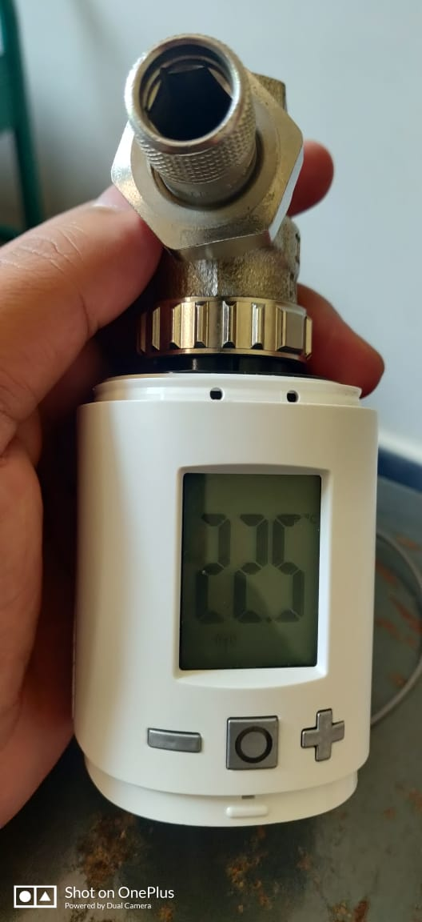

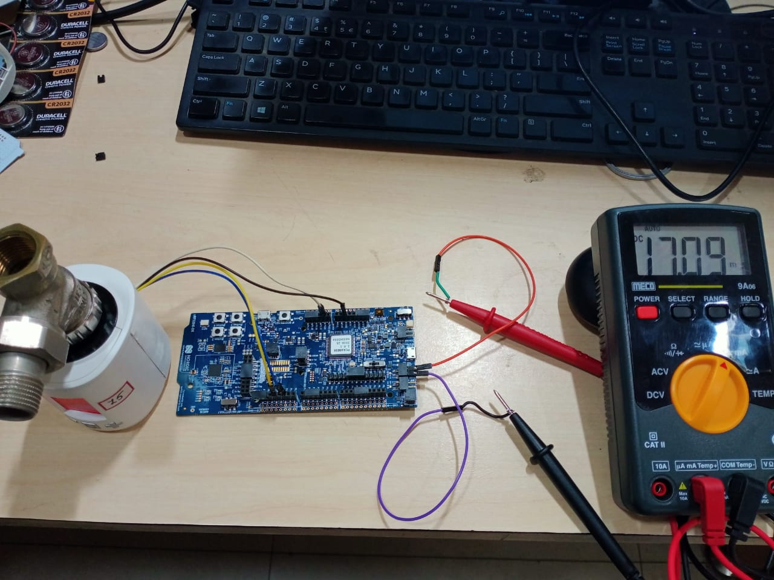

**- We followed the steps from nrf52840 user guide to cut the SB40 and connect the multi meter to P22 as per document. And "You should also set SW6 to "nRF only"" this part was not mentioned in user guide so we kept in default only and tested current. Now I will test with this Configuration too.**

**- We are using coin cell to measure the current as per guide note. Before discovery we get current around 15mA and after discovery is done once stabled we get 1mA. And if any command exchange current again goes to 15mA and after completion stables for 1mA. While measuring current without enabling "SW6 to nRF only" I came across one observation that,. After discovery process done and device connect to gateway we get reading as 1mA but after 4 to 5min automatically dev-kit on board discover LED turn OFF. Also, we get same current reading as coin cell when we use USB to power up though it not recommended in guide docs.**

**- From one of the post from forum, we can power down the unused ram section. As per my understand I enabled the below line in code to power down the unused ram. Let me know If I followed any wrong method here.**

**- Please find the attached memory usage image and let me know what I did wrong in code power down ram.**

* **memory image -**

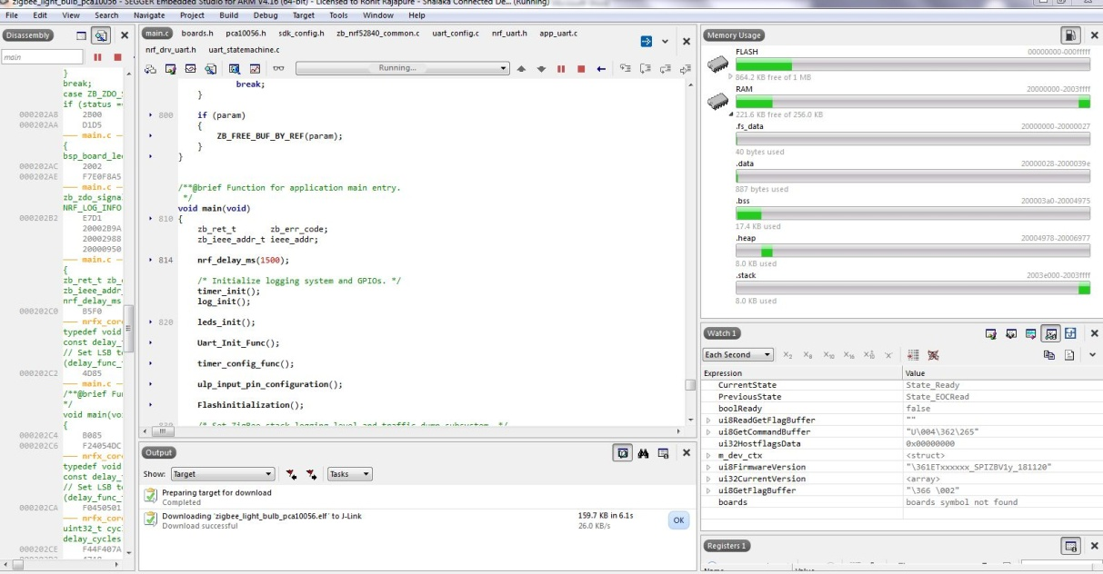

**-** **To enable SED I have referred the "multi sensor" example.**

**- Please find the attached main.c file of my project. Only thing is I have not used** [**zb_sleep_set_threshold()**](https://developer.nordicsemi.com/nRF_Connect_SDK/doc/zboss/3.6.0.0/group__sleep__api.html#gaad0eff89b2a0ea803f70d7888bea355e)**function as it is not present in multi sensor example. So tested with minimum configuration. Let me know Effect and any changes I have missed to enable SED.**

**- Let me know your feedback on my points and correct me I am following any wrong steps here.**