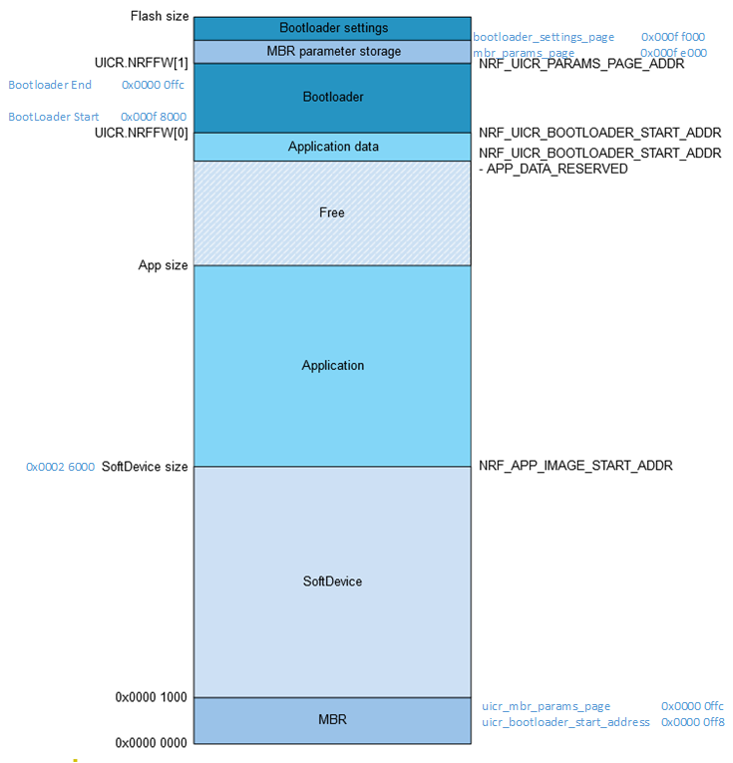

Memory Map, with some helpful locations.